Menus at your Fingertips!

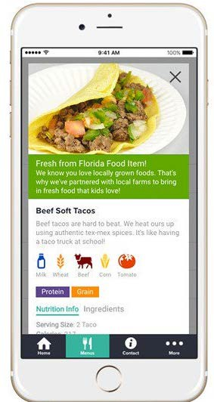

Easy ordering on the go!

* Pre-Order & Pre-Pay (Visa, Mastercard or Visa Debit)
* Order Monthly, Weekly or Daily before 8am
* Healthy, balanced meal choices
* Contactless
* Cancel meals in advance for a full refund right from your order history

**Download the Free Nutrislice app from the app store or**

**visit Chartwellsk12.ca**